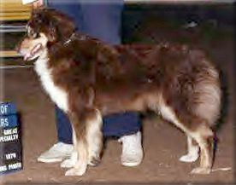 | 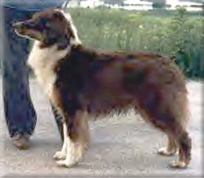
Fairoaks Sheba  (Ch. Chulo and Fairoaks Shanna)  Owned by Zeno & Ruth Nordwick,  Shown by Rose Spicuzza  Best of winners - Great Lake Specialty 1979  (23 dogs, 35 bitches).  Dam to Fairoaks Hi Winds Reno,  Ch. Fairoaks Medicine Wolf CD,  (Owned by Kris Toft) | Fairoaks Hi Winds Reno  (Fairoaks Bo x Fairoaks Sheba)  23", OFA good, eyes clear  Sire to: Fairoaks Shakana
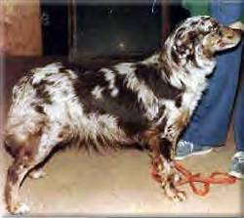 | 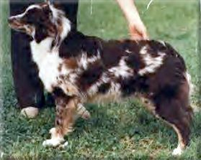
Fairoaks Sweetwater Holly  (Ch. Chulo Rojo of Fairoaks x Fairoaks Cheena Rose CD)  Dam to: Fairoaks Raushana | Fairoaks Raushana  (Fairoaks Matayo x Fairoaks Sweetwater Holly)  1980 - 1994  Red merle
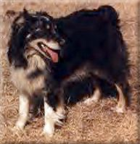 | 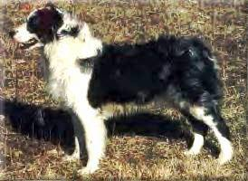
Fairoaks Fine Chrystal  (Ch. Chulo x Fairoaks Tamarin)  Dam to: Fairoaks Arabesque | Fairoaks Arabesque  (Ch. Chulo x Fairoaks Fine Chrystal)  1984 - 1998

